**C:\Users\st11223\Desktop\MIT LOGO ETC\New MIT Logo.png** 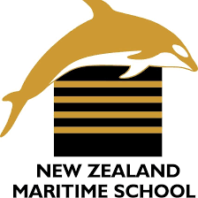

**NEW ZEALAND MARITIME SCHOOL**

**NZ Diploma in Marine Electro-technology (NZ2894)**

**(STCW 1978 A-III/6, as amended in 2010)**

**Electro-Technical Officer, Year 2 Cadets, 2020.**

**Course Code**

942.634 – AS01.

**Course Title**

Operation of Generators and Distribution Systems Learning Outcomes Assessment.

**Format**

Written assignment of 800 words including diagrams and marked Competent (C) or Not-Yet Competent (NYC). Weighting = 50%.

**Due Date**

To be submitted by email to [nick.cossar@manukau.ac.nz](mailto:nick.cossar@manukau.ac.nz) for the due date of 31/05/2020.

**Tutor**

Nick Cossar

[nick.cossar@manukau.ac.nz](mailto:nick.cossar@manukau.ac.nz)

**Student Name:** Levi Dubbelman

**Student ID:** 190000929

**Date:** 01/06/2020

Outcome 1: **Demonstrate an advanced knowledge of the coupling, load sharing and changing over of generators to enable load sharing and change over.**

* explain rules for parallel working of generators

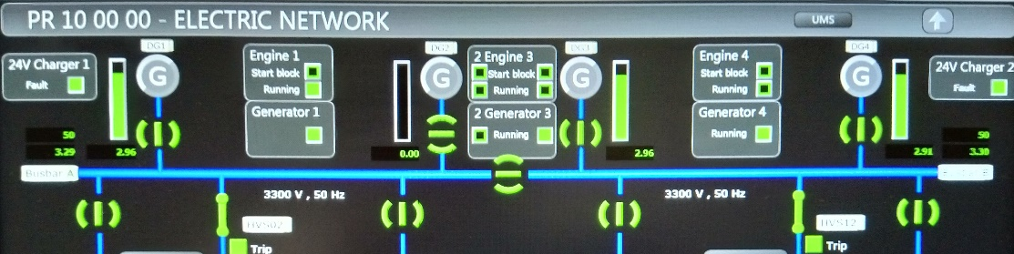

The DEV *Aratere* electric network page showing the four main generators, three of which are running in parallel.

There are three key requirements to successful parallel operation of generators. These are:

**Frequency**

All generators on the grid must be producing a waveform of the same frequency. Small variations are corrected upon closing of the breaker, however, any variation is likely to cause a sharp current spike due to reverse power. Frequency is tied to the RPM (and number of poles) of the generator. It is therefore preferable to have identical generators (e.g. 1000/1200 RPM at 50/60Hz) to avoid any quirks that arise from different RPM generators in parallel.

For this reason, it is not appropriate to run a shaft generator in parallel with a traditional diesel generator set for any extended period of time, as fluctuations in the ship’s prime mover due to constantly changing sea conditions may cause severe mechanical stresses on the diesel generator as their RPM is forced up or down rapidly.

**Voltage**

Any generators in parallel must be producing the same voltage. As with frequency, small variations will be corrected forcefully when there is breaker action. However, generators must produce a similar voltage waveform or a reverse power situation may occur.

**Phase Sequence**

When parallel action occurs, it is paramount that the incoming generator has a near-perfect level of phase sequence to the existing grid. If the generator does not have the same phase-sequence, then a reverse power or, in worse case scenarios, short circuit condition may occur.

It is also worth mentioning that while different RPM/pole configurations may be run in parallel, inverter generators (generators which take a DC or pre-existing AC voltage and convert into a different waveform) may never be run in parallel, even with each other. Although this is not normally an issue as inverter drives are usually just before their appropriate consumer on the distribution board.

* explain methods for synchronization of the generators to the busbars and describe the differences between the following methods:
  + automatic synchronization

Automatic synchronization is almost exclusively hands-off. Power Management System will, when there is a change in loading (either increase or decrease), begin the start up or shut down of generators automatically. During this mode, it will also balance load-sharing between all generators, to maximize fuel efficiency and reduce stresses on the mechanical components.

* + semi-automatic synchronization

In Semi-Automatic synchronization, power management will assist in synchronizing by closing the breaker when the phase sequence, frequency, voltage and RPM of the machines fall within acceptable parameters. This is best utilized during transitions between modes, e.g. “pipe laying mode”, “port mode”, “sea mode” etc where the expected load is pre-planned to ensure the required number of generators are available during mode transitions.

* + manual synchronization

Manual synchronization is entirely hands-on, with very little assistance from the power management system. In this mode, a synchroscope is required to ensure correct phase sequence, and full governor control is in the hands of the crew. This mode is likely the least used of the three, however it is important that there is proper understanding behind the process of manual synchronization, in the event of a power management system failure.

* describe generator voltage and frequency control systems

Generator voltage control is primarily handled by the AVR or DVR units associated with the diesel-generator set. This unit’s job is essentially to take information about the voltage produced by the generator, and either increase or decrease the rotor’s rectifier’s excitation based on those results.

Frequency is tied directly to a generator’s RPM – and therefore the most effective frequency control available is governor control on the diesel driver side of the generator set. Power management will take the frequency produced by the generator – as well as the RPM of the set with a tachometer, such as a rotary encoder, and adjust the amount of fuel injected into the diesel driver as needed.

* explain the meaning of power factor

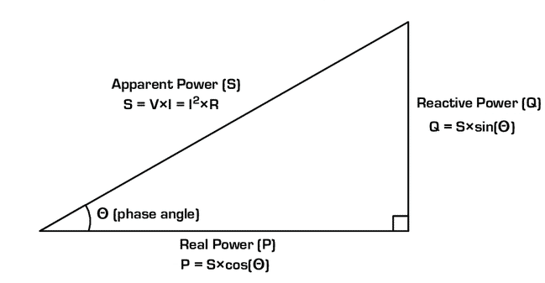b

Power factor, or cosine theta, is the expression of the cosine of the angle between apparent power and real power on a right-angle triangle. This reflects the efficiency of the power system – a high power factor (close to 1) means that the system is very efficient, as very little power is wasted on reactive power. A low power factor (close to 0) means that a lot of power is wasted on reactive power. This situation is not ideal, as reactive power is not able to provide “useful” work.

* describe excitation systems of generators and explain why rotating rectifiers are essential

The following is an excerpt from Dennis T. Hall, Practical Marine Electrical Knowledge 3rd Edition, page 55 Chapter 3.3 “Excitation Methods”

The two factors essential for the production of a generated emf in an AC generator are rotational speed and magnetic flux. Field windings on the rotor create strong magnetic field poles when direct current is passed through them. Various methods have been devised to supply the correct DC field (excitation) current to produce the required AC output voltage from the stator terminals. The excitation must be continually regulated to maintain the generator output voltage as the load power demand fluctuates.) Excitation methods are either rotary or static. A rotary method utilises an exciter, which is shaft-mounted and rotates with the main generator rotor. The most common arrangement is to use a shaft-mounted AC exciter.) In some applications, a small additional rotary pilot exciter may be used to supply current to the main exciter field. A pilot exciter is a small permanent magnet AC generator that is driven from the generator shaft. Its output voltage is generally at a high frequency (e.g. 1000 Hz) but this is changed to DC before being fed into the main exciter field.)

Essentially, without rotating rectifiers, a complex brush-commutator arrangement would be required for excitation, which would be inappropriate for constant use due to the high maintenance requirement.

* describe safety systems of generators and their diesel engines

Diesel generator sets have several safety pre-checks and operational safety setpoints for various feedback inputs. These include:

* + Control Power
  + Short-circuit
  + Overload
  + Reverse Power
  + Fuel pressure
  + Preheating
  + Lubrication pressure
  + Sea water and fresh water cooling temperature and pressure
  + Start air pressure

During normal operation, setpoints exist for:

* + Exhaust temperature
  + Stator temperature
  + Over/underspeed
  + Under/overvoltage
  + Under/overfrequency
  + Turbocharger temperature
  + Overcurrent
* list parameters and limits for the following generator and diesel engine protections:
* short-circuit protection

Short circuit protection exists to trip the generator’s breaker in the event of a massive current draw, so great that it would only occur in a phase-to-phase or phase-to-earth short circuit. While this protection is fantastic for “pure” short circuit conditions, especially on the main busbar and its direct consumers, it does not provide significant protection for an “impure” short circuit which may occur due to insulation breakdown, as the current draw may be too small, relatively speaking, to trip the breaker.

* overload protection

Overload protection exists to prevent overheating of the stator windings on a generator, as well as to prevent mechanical stresses on the diesel engine, in the event of a significant current draw (though not significant enough to warrant a short-circuit trip). This protection is effective against high load situations for extended periods. It works well with “preferential trips” as unnecessary consumers on the board are taken off to prevent the overload condition from forcing the generator offline.

* reverse power protection
* 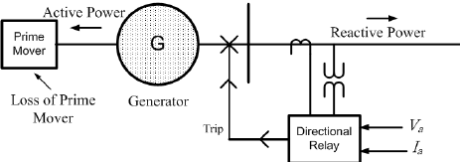

Reverse power occurs when current is allowed to flow into the generator, forcing it to act like a motor. When this happens, it is a potentially dangerous situation, as the rotational energy of the diesel engine is in direct opposition to the rotational energy of the “motor”. This can cause shaft warping. Reverse power detects when a significant amount of current is allowed to flow in the incorrect detection and disconnects the breaker to prevent any permanent damage.

* under and overvoltage protection

Under and overvoltage protection exists to prevent both reverse power or consumer damage situations as well as stator overheating by opening the breaker to a generator producing an incorrect voltage. Generally, this is handled by the AVR, but in the event of an AVR failure or excitation failure, under and overvoltage protection will prevent any potential damage.

* under and over frequency protection

Under and over frequency protection exists to prevent damage to consumers being supplied by the generator. A variation in frequency is caused to a variation in engine RPM, and a breaker will act to prevent frequency-dependent consumers such as motors, and compressors, which may overheat or behave poorly due to a supply frequency they are not designed for.

*Anecdotal note: an electrician on the Aratere told me about a 50Hz air compressor used on the Kaitaki (a 60Hz vessel) which exploded violently after several minutes of use. Nobody was injured, but that mistake was never repeated.*

* asymmetrical voltage and current protection

Asymmetrical voltage/current occurs in the instance of a fault. According to the IEEE, asymmetrical current values may be as great as 2-2.7x the RMS current of a fault. These protections exist to measure the rate-of-rise of outgoing current from a generator, and any spikes of sufficient magnitude are broken before they can do significant damage.

* describe methods for frequency and voltage stabilization of shaft generators

As with traditional generators, voltage control is achieved by an increase of current to the exciter. The amount of current added into the system is determined by an AVR which takes feedback from the voltage being produced by the shaft generator.

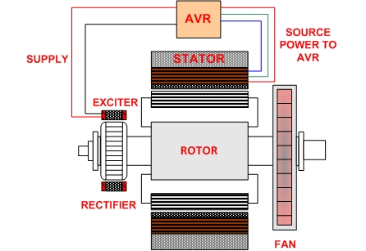

For frequency control, typically the shaft will drive a transmission taking the relatively slow RPM of the prime mover’s shaft and increasing the ratio such that it is able to drive a generator at a higher RPM (depending on desired frequency), e.g. 100 RPM to 1000 RPM as a 1:10 transmission.

Therefore the primary source of frequency control for a shaft generator is control of the main engine’s RPM. Secondary sources of frequency control may be employed, such as a beier variable ratio gear set or continuously variable transmission (CVT).

* describe the electrical energy balance of the vessel

Load balancing, or load sharing, is where two or more generators are running parallel with each other. This drastically increases redundancy, and generation flexibility. By having several smaller generators, rather than one large generator, generators may be taken off the grid for maintenance while the vessel is in operation and allows for better fuel efficiency due to different power requirement circumstances allowing different configurations of generators.

There are situations where it is preferable to have one generator on the grid – for instance, a gas turbine generator to minimize emissions, or a shaft generator to utilize the prime mover’s excess power generation. However, additional generators will be standing by if needed, for example when load shifts occur (bow thruster), circumstances change (main engine reduced speed) or failure in another generator.

Outcome 2: **Demonstrate an advanced knowledge of the coupling and breaking connection between switchboards and distribution panels to enable load sharing and change over**

* describe systems of generation and distribution of electrical energy on vessels
* explain the construction, equipment and the service of main switchboard
* explain construction, equipment and service of emergency switchboard and distribution panels
* describe construction and operation principles for measuring instruments used in main and emergency switchboards and distribution panels with specific reference to:
  + voltmeter
  + ammeter
  + wattmeter
  + frequency meter
  + synchroscope
  + power factor meter
  + earth fault meter

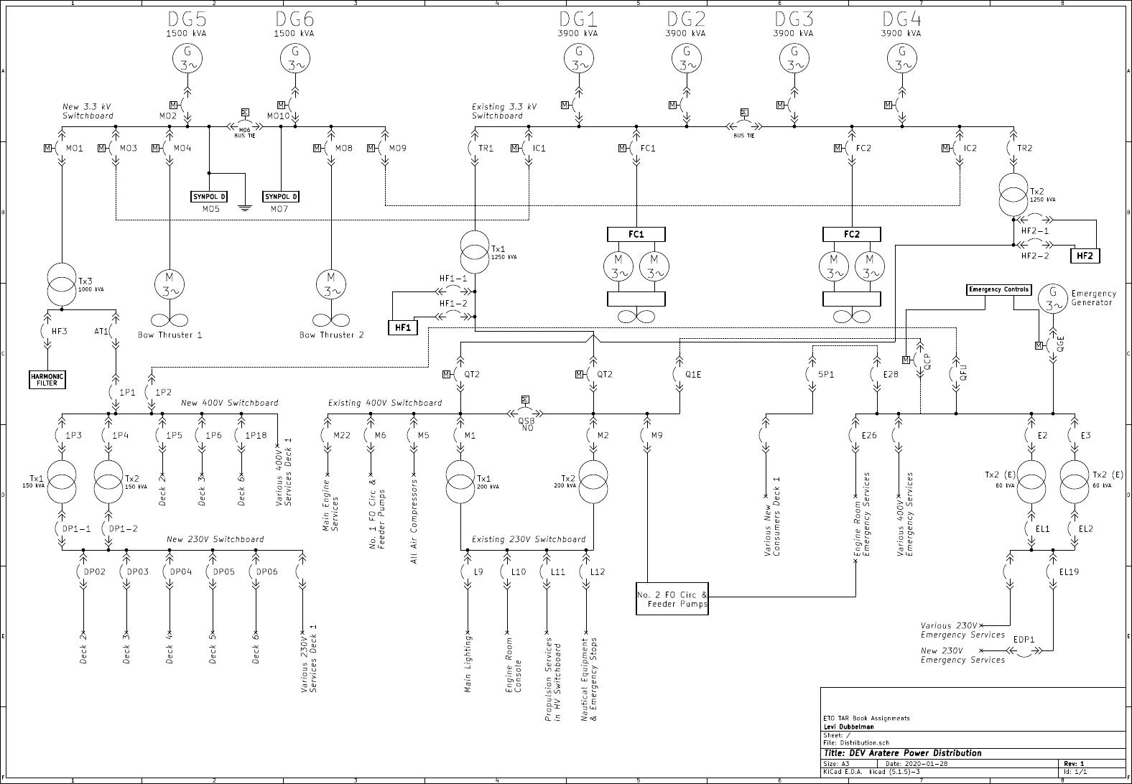The main distribution diagram of the DEV *Aratere*

The generally accepted standard for the electrical distribution systems on vessels is one or more diesel generators, with a backup emergency generator as redundancy. The emergency generator (and switchboard) will be located as high as possible on the vessel to continue operation for as long as possible if the vessel is sinking. This switchboard will include the most important consumers which are critical to the safety of the ship, her passengers, and her crew, as well as consumers required to start one of the main generators, such as an air compressor, a lube oil pump, etc. These consumers can run off the primary generators of the vessel in the normal operation of the vessel, via a bus tie which connects the emergency bus to the main bus. (There are interlocks preventing this bus tie being closed while the emergency generator is on the grid)

In addition to the main switchboard, several secondary cabinets exist known as local panels. Breakers for these local panels will be on the main switchboard, while breakers for individual components are found on the local panel. This allows for precision when diagnosing or performing work on any component of the system. In addition, this allows for discrimination when a problem arises unexpectedly, allowing the consumer responsible to trip its own breaker, rather than taking everything else down with it. Both the main switchboards, secondary switchboards and local panels can all be disconnected and isolated, allowing for new installations or work to be done in them. Their construction is generally modular, allowing for DIN rail compatible breakers and other switchgear to be swapped in an out freely.

Generally, wires will be connected to the bottom of switchboards and panels to prevent ingress of foreign materials, such as water or dust, through the glanding.

Cable sizing may also vary greatly with expected voltage and current. For example, the generator cables feeding in to the main bus bar may be several centimetres thick, with a massive layer of insulation, whereas cables for control systems or other low voltage or low current systems may only be a few millimetres thick, with some easily penetrable insulation.

Because of the wide assortment of cable types and sizes with varying degrees of insulation and protection, earth faults are somewhat common. This is another advantage of having a modular, component driven setup, allowing crew to narrow down the location of any potential issues using earth fault indication meters, as well as insulation testers known as “meggers”.

Each switchboard will also include several instruments providing real-time information about the switchboard. Breakers are front-mounted and provide clear indication when tripped. Voltmeters show the presence of voltage, as well as the kind of voltage within the board. As do ammeters, and power meters, which use coils connected to the bus bar itself to render this information.

When paralleling generators, a synchroscope is also mounted on a special panel known as the synchronization panel. This special instrument provides an easy-to-interpret method of seeing the phase sequence of an oncoming generator vs the existing grid. Generally, these panels will also include manual governor control, allowing that phase sequence to be modified with the RPM of the generator.

­

* explain construction and operation principle of circuit breakers and their tripping devices

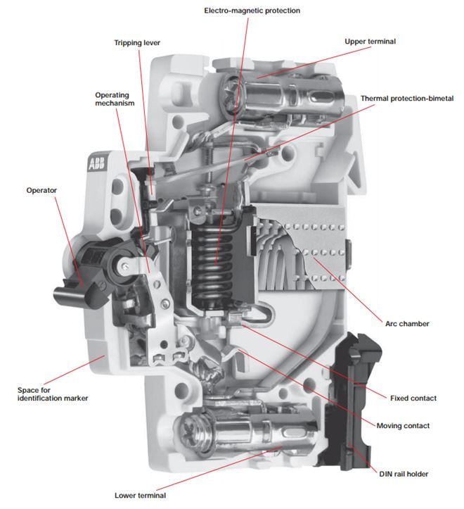

Standard circuit breakers may act on one of two methods—

**Magnetic Action (MA)**

Magnetic Action occurs when a sufficiently large enough current is drawn to earth or between phases to actuate a solenoid within the circuit breaker. When this occurs, the solenoid forces the mechanism open, usually within a fraction of a second. Different breakers are rated to different magnetic acting curves, allowing for situations such as the starting of a large motor, which has a pseudo-short circuit effect during the establishment of its magnetic flux.

**Thermal Action**

Thermal Action occurs when an overcurrent situation is allowed to continue for an extended period of time. This time is defined in a current-time curve. The higher the current, the faster the thermal buildup, and the faster the thermal action. A bimetallic strip bends with the application of heat and presses against the trip bar when sufficiently heated.

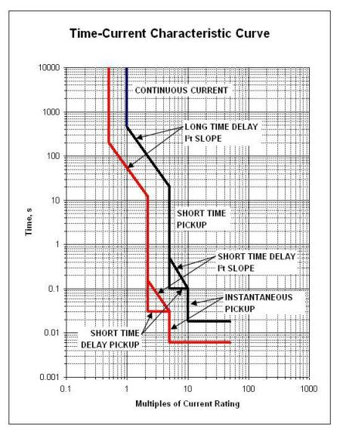

* explain procedures for restarting vessel equipment, after power supply failure (black-out) on board
* describe conditions for automatic start of emergency generator and starting methods

Emergency generators will start upon detection of a power failure on the main switchboard. Emergency generators may start through either battery/starter motor, air, hand-pump hydraulic, spring start. Of key importance is the need for two separate starting methods, as required under SOLAS.

Each ship will typically have their own unique quirks in their blackout procedure. The order of operations is as follows:

Emergency Generator | Emergency Consumers | Diesel-generator start-up | Other consumers

For a more specific example, this is the (unofficial) start up procedure for the DEV *Aratere.*

The new engine room has a main and an emergency board in it. DG5's fuel pump, cooling pump and one seawater pump are fed from the emergency board. DG6's and the other sea water pump are fed from the main board.

If the main engines are lost due to an HT or LT fault or Fuel Module failure, thus creating a delay in the restarting of DG's 1 through 4, the new engine room can be utilised.

One small alternator would be started automatically via SYNPOL if it is in Auto and placed on the board. Once this occurs, the Emergency Generator will stop, and supply will be from the Main Transformers. The new 400v board will need to be livened by closing the 400-volt breaker. Then the ancillaries i.e. fuel pumps, and cooling pumps for the new engine room, which can be started via ADVANT, can now be started. If required, the other small alternator can then be started.

Note: both must be on the board to get propulsion.

The Sea Water pumps are working in Auto on a Duty/Standby configuration, if Pump 1 (Main Board) is Duty, then Pump 2 (Emergency Board) will be started automatically. Otherwise Pump 2 or Pump 1 will need to be started once the alternator is supplying load.

So, for DG5: that has its auxiliaries fed from the emergency board, and once it has taken load:

Start HFO Pump 2, and DG5 cooling pump. Check to see if a Sea Water Pump is running. Close the New 400-volt switchboard breaker.

Reset FD 106 and FD 153 as well as starting all fans and pumps on New 400-volt board.

For DG6: that has its auxiliaries fed from the Main 400-volt Board, and once it has taken load and the New Switchboard breaker has been closed, Start HFO pump 1, and DG6 cooling pump. Check to see if a Sea Water Pump is running. Reset FD 106 and FD 153 as well as starting all fans and pumps on New 400-volt board.

NOTE: If the Emergency Generator fails to start, DG5 or DG6 can be switched to Shutdown Override and switched to Auto on ADVANT, when either one should start and go on the board. If the generator does not start automatically, it can be started by the manual start button on the Start solenoid and placed on the board using SYNPOL. The above steps for reinstatement of Auxiliaries should be followed.

* describe connection between main and emergency switchboards and necessary safeguards

The main and emergency switchboards are connected by a feeder known as the transfer line. This bus connector allows for all emergency loads to be powered by the primary generator sets during the normal operation of the vessel. However, the interconnector will open upon catastrophic power failure, allowing the emergency generator to safely close its own breaker to the emergency switchboard when it is up to speed.

Generally, it is not possible for the emergency generator and the primary generators to run in parallel, and all generators will have a reverse power, undervoltage, overvoltage, underfrequency and overfrequency trips to protect both the generators and the consumers.

* list equipment typically supplied from emergency switchboard

Emergency Switchboards generally house every circuit required for the safety of the crew, as well as whatever is required to restart a primary generator. These may include:

* + Navigation Lighting
  + Bridge Lighting
  + Steering Pump
  + Fresh Water Pump
  + Seawater Pump
  + Fire Pump
  + Air Compressor (typically a separate “emergency” compressor)
  + Emergency Lighting
  + Marine Radio
  + FO Pumps
  + Boiler Burner (if applicable)
  + Battery Charging / UPS
* explain procedure for change-over to shore-connection supply

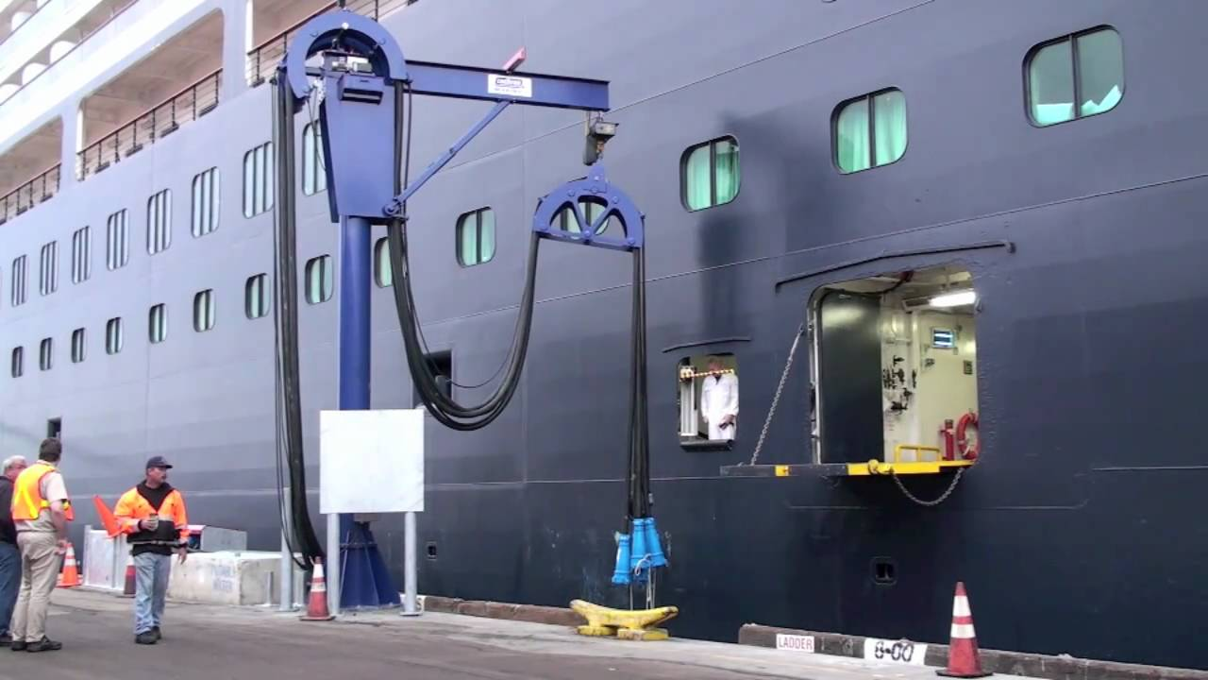

The Port of San Diego’s shorepower connection

The following is an excerpt from Dennis T. Hall, Practical Marine Electrical Knowledge 3rd Edition, page 33 Chapter 2.7 “Shore Supply Connection”

At the main switchboard, an indicator is provided (usually a lamp) to indicate that the shore supply is available for connection to the busbars via a connecting switch or circuit breaker. In general, it is impossible to parallel the shore supply with the ship's generators. The ship's generators must, therefore, be disconnected before the shore supply can be connected to the main switchboard.) Normally, the shore switch on the main switchboard is electrically interlocked with the generator's circuit breakers, so that it cannot be closed until the) generators are disconnected from the ship's mains (as this will cause a brief mains blackout before shore power is applied).)

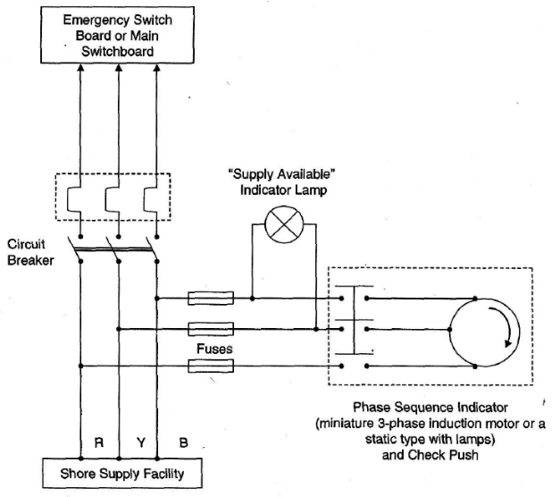

**Resources**

* + CANVAS course 1.
  + Hall – Practical Marine Electrical Knowledge.
  + Hughes – Electrical and Electronic Technology.
  + Lloyds of London Rules and Regulations for the Classification of Ships July 2018.